Section 5- UI FOR AI/API IMPLEMENTATION
5.1 Introduction to AI/API Implementation
- The Online Tutor Marketplace system leverages AI and API capabilities to enhance tutor recommendation, booking processes, and user experience. The AI matching system guarantees that students can discover a tutor which matches their requirement, spending budget, time zone, rating, and learning style. APIs are used to provide communication, notification, and payment processing functions that can be powered by AI.

5.2 AI MATCHING UI
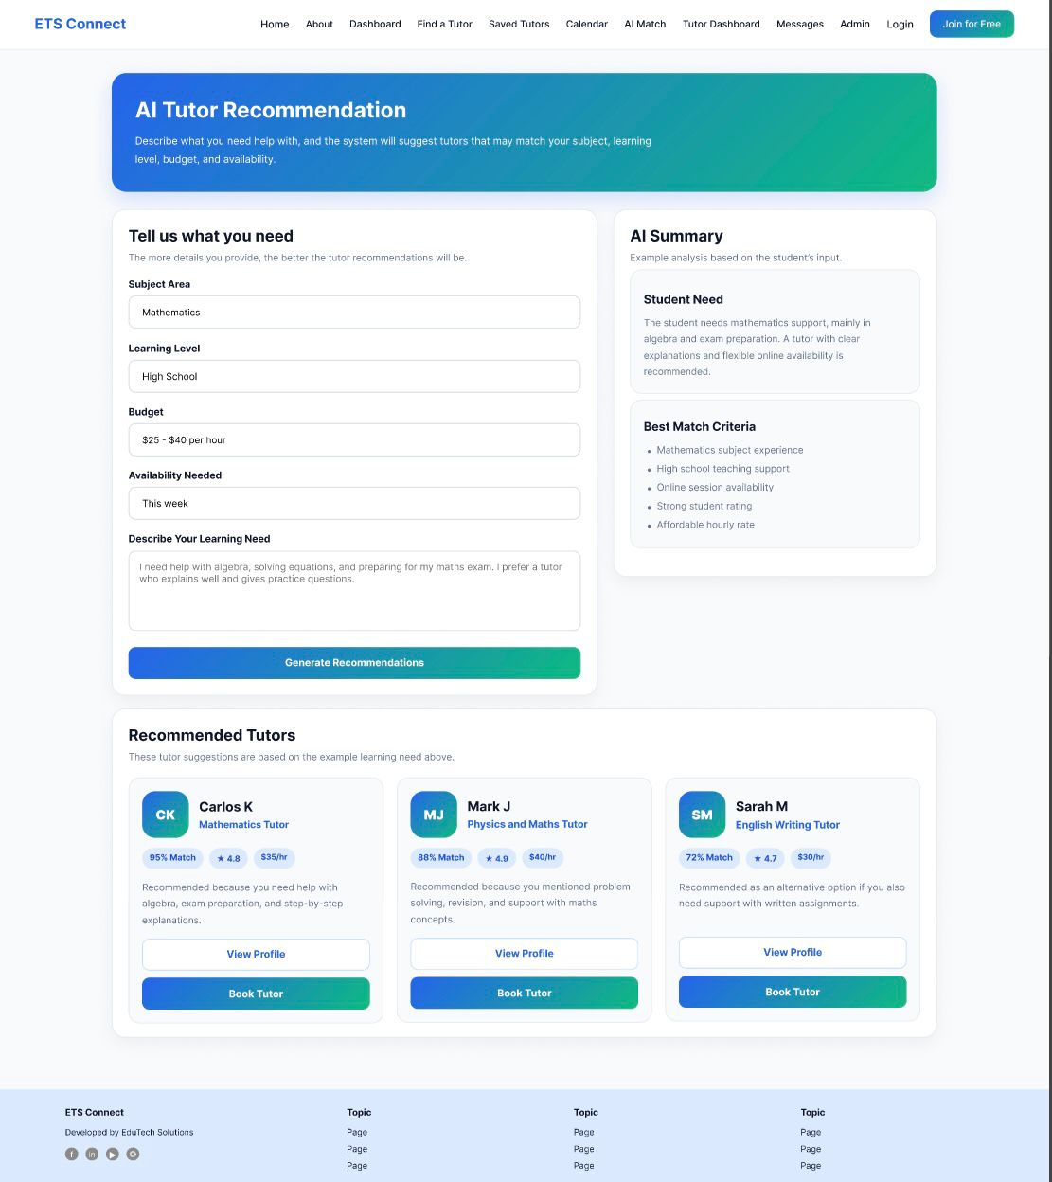
5.2.1 Smart Match Homepage
Students can enter learning preferences like subject, budget, time zone and learning goals at this interface. This information is then fed into the AI system which suggests the best answer to the learner, based on the tutor.
5.2.2 Smart Match Quiz Form
Information about students learning needs is gathered in the quiz form. This helps the AI recommendation engine to provide personalized tutor matches.
5.2.3 AI Match Results
The system provides suggestions from tutors according to their compatibility to the students, the subject's relevance, the tutor rating, and the student's preference.

5.2.4 Tutor Search Results
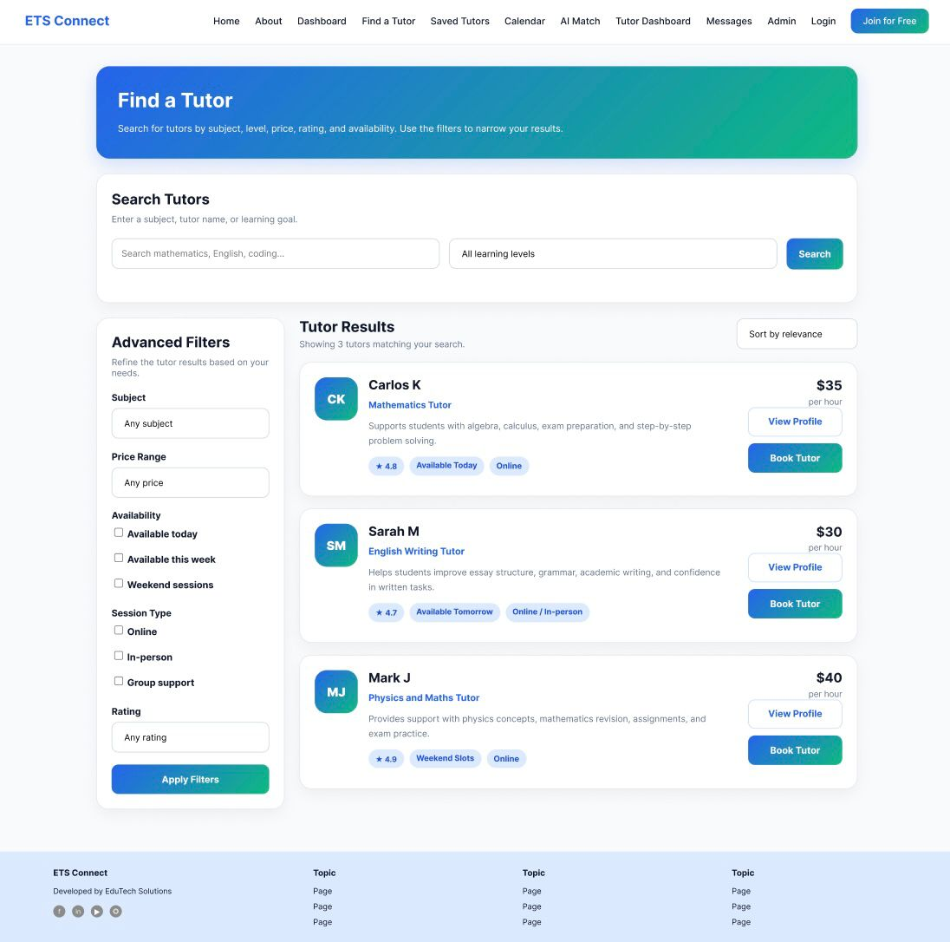

- Tutors are recommended by the AI matching system according to the student's preferences and compatibility analysis, and the recommended tutors will be displayed on the Tutor Search Results interface. Students can rate, experience, subject expertise and price tutors for comparison.

5.2.5 Filters Interface


- Students can narrow down the tutor recommendations within the filtering interface, based on their specific preferences, like the budget, the location, the mode of the session, the tutor's rating, or the subject.

5.2.6 Saved Tutors
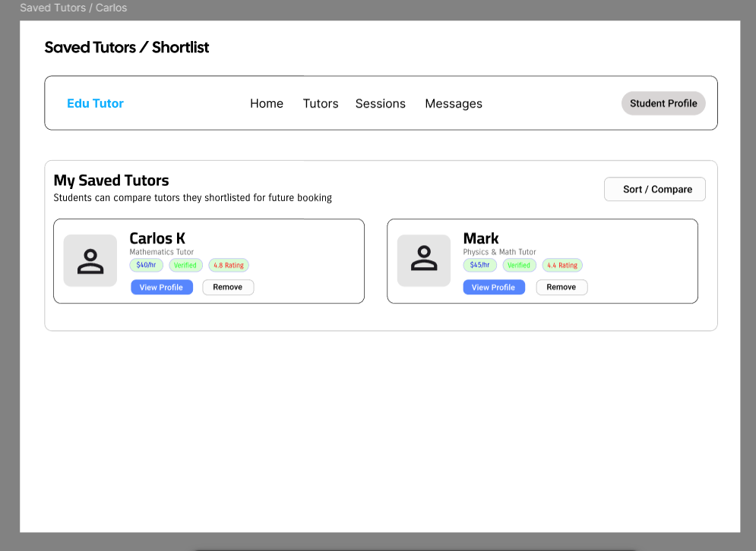

5.3 OpenAI Usage

5.3.1 AI Chat Interface (Chat Interface and Chat List)

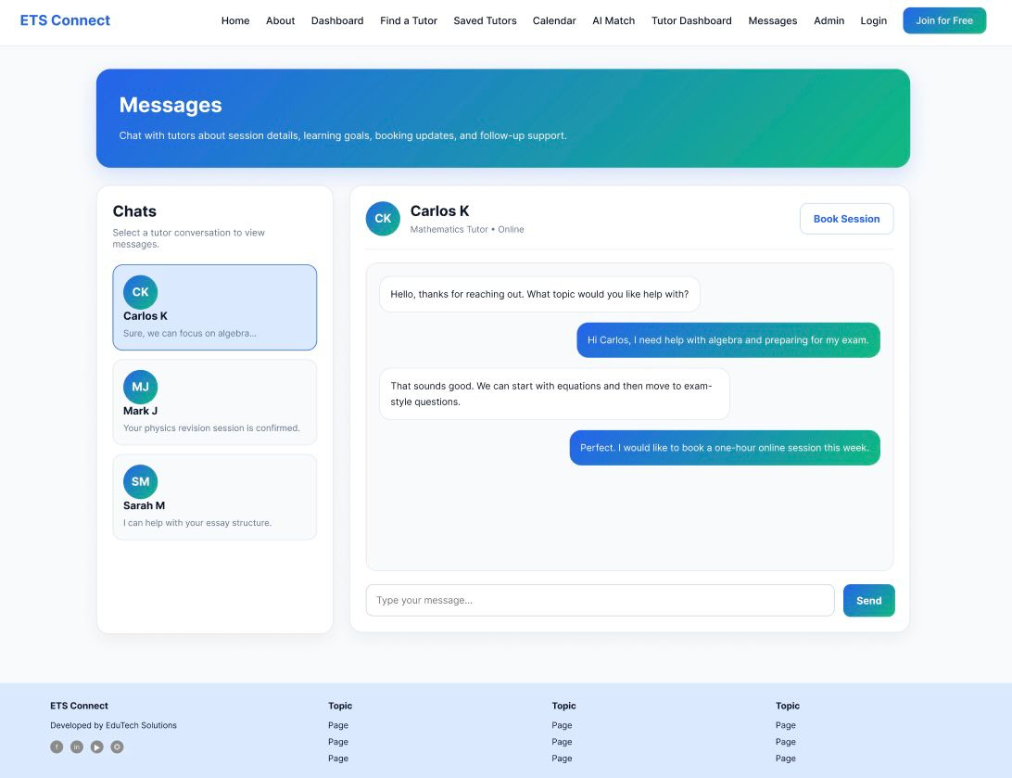

5.3.2 Features Supported by Open AI

Feature | Description
AI Tutor Recommendations | It suggests tutors based on student preferences
Smart Matching | Matches students with suitable tutors
Chatbot Support | Provides automated assistance
AI Moderation | Detects inappropriate messages
Personalized Suggestions | Gives learning recommendations

- The Saved Tutors feature lets students save AI-recommended tutors by comparing them with their future bookings and make it easier to manage bookings.

5.4 Tools and Technologies Explanation

Tool/Technology | Purpose
Open AI API | AI recommendation and chat box support
Figma | UI/UX wireframe design
Draw.io | DFD and system diagrams
Visual Studio Code | Website development
HTML/CSS/JavaScript | Frontend development
Nod.js/PHP | Backend Processing
MYSQL | Database Management
GitHub | Version Control
Stripe API | Payment Integration

- These tools and technologies have been utilized in the design, development and integration of AI-powered features into the Online Tutor Marketplace system.

5.5 API Integration
To communicate between different services and system components APIs are used in the system. The tutor suggestion and AI-enhanced support features use OpenAI API. Secure payment processing is done by Stripe API, and notification API is used to send reminders and booking alerts for users.

API | Purpose
OpenAI API | AI recommendation and chatbot
Stripe API | Safe payment gateway
Notification API | Booking reminders and alerts

5.5.2 Reminder Interface

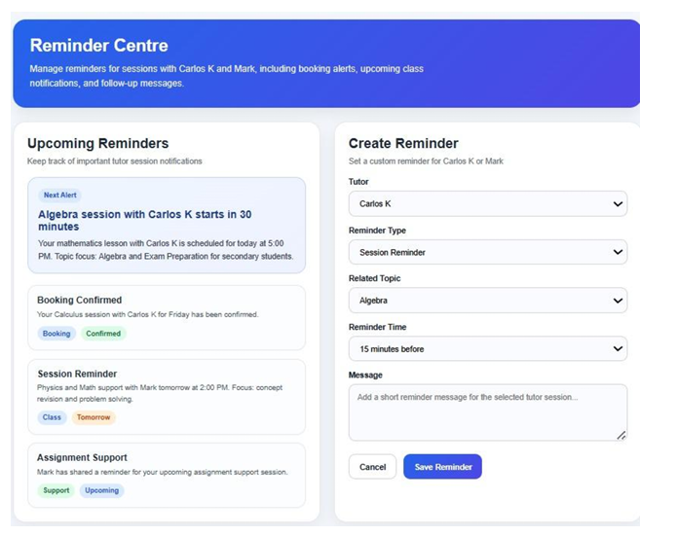

- The reminder device/interface provides reminders of future tutoring sessions, bookings and agenda updates.

5.5.3 Booking Request Interface
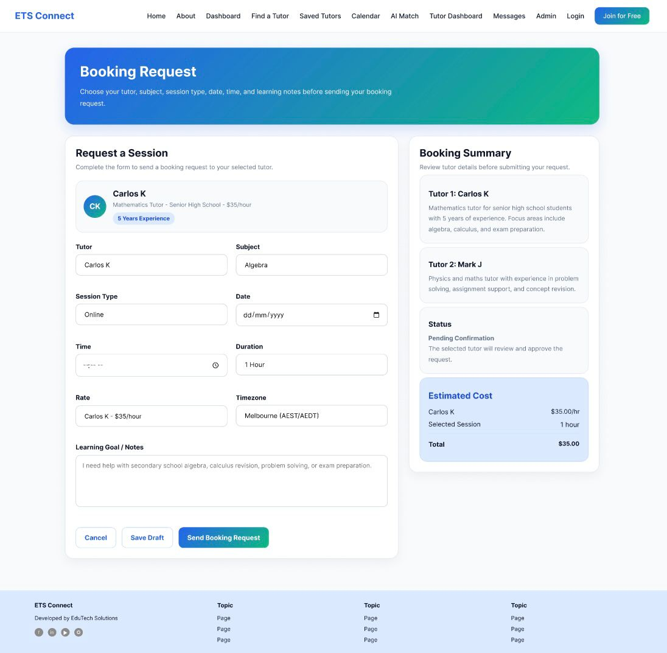

- Students can post a tuition advice request by selecting favoured teachers, semester dates, and study requirements.

5.6 Screenshots and explanations
5.6.1 Student Dashboard
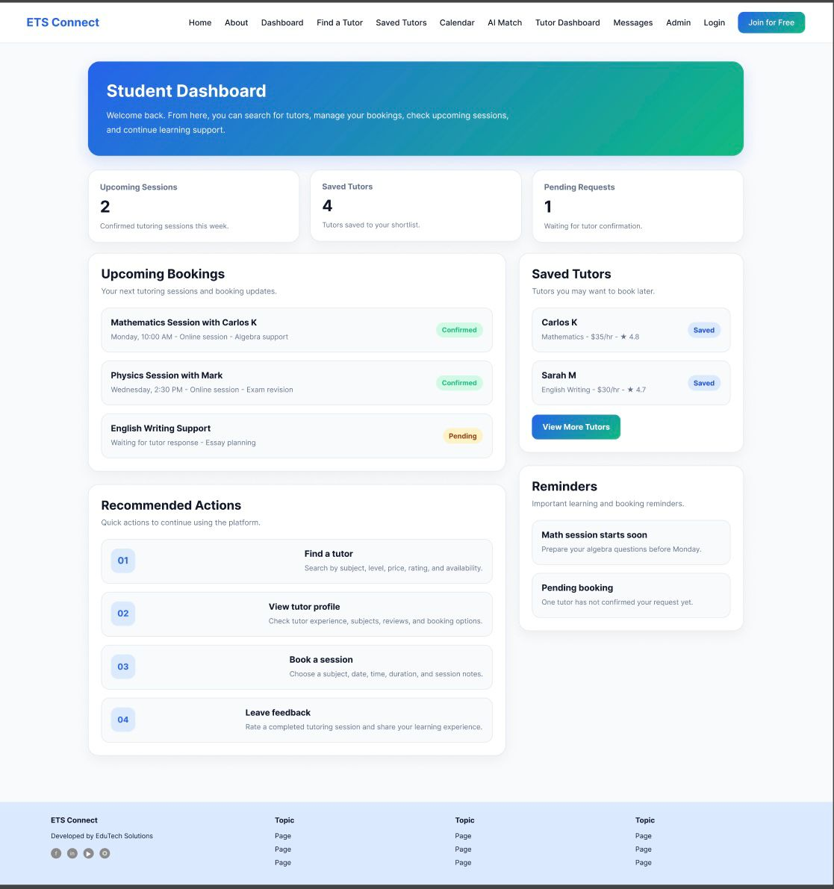

- The student dashboard provides short reach access to coach signals, bookings, schedules and archived tutors.

5.7 System Architecture Diagram
5.7.1 Frontend Backend AI/API Flow Architecture Diagram
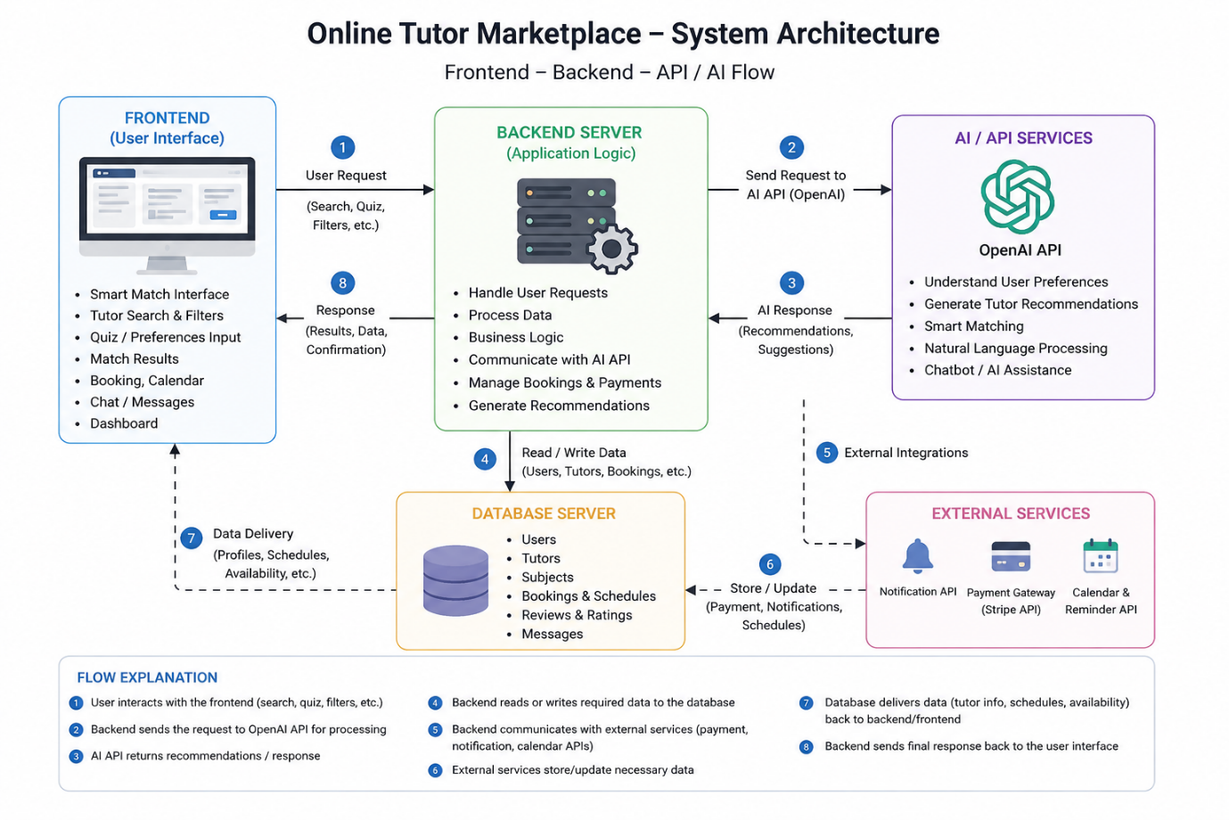

Online Tutor Marketplace architecture follows the frontend-backend-AI architecture approach. Frontend interface serves as the platform that enables interaction between the users and the tutors while preferences and booking can be done through it. As soon as the user asks for something, the backend server processes the request and interacts with the OpenAI API to find intelligent tutors. The backend server also retrieves tutor details from the database. There are external APIs such as payment gateway and notification APIs that provide booking features as well.

AI CHATBOX [AI Assistant]
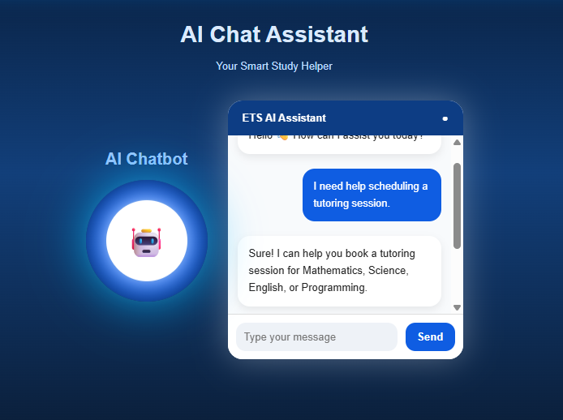

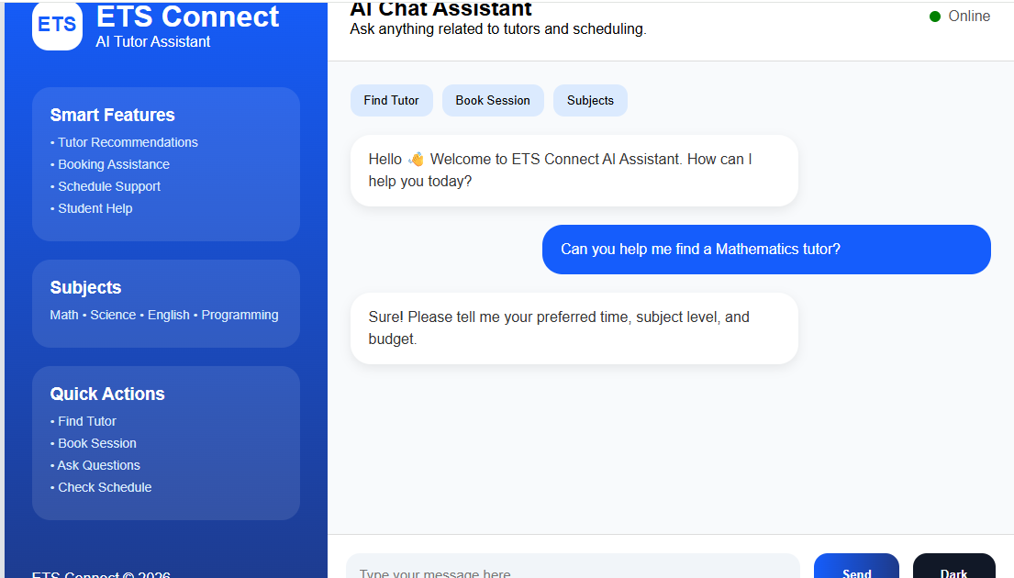

AI Chat Box Interface: Students and tutors can chat with the AI assistant for fast assistance and directions in the Online Tutor Marketplace system. The chat box is seamlessly connected to the OpenAI API to deliver intelligent responses, tutor recommendations, booking assistance, and learning suggestions.
Students can ask questions about following points:
- Tutor recommendations buttons
- Booking support
- Schedule checking
- Study guidance
- Smart AI replies
- Interactive chat system
- User-friendly AI interface
- Instant response simulation
- AI assistant design/theme

Purpose of AI chatbot
The AI chat box is meant to make it easier for students to talk to others and to make the Online Tutor Marketplace system work better. It does this by giving help answering questions quickly and helping students find the right tutor for what they need to learn. The AI chat box is a help to students because it is fast and accurate and it makes it easy for them to find a tutor that is just right, for them.

